# Software Design Document

## 1. Introduction

Today, with cloud becoming more and more used, collaboration becomes easier and more efficient. The purpose of this application is to provide a mobile-friendly collaboration planning application to help make collaborations easier to handle and to make communication of ideas flow smoothly. The application will help, display user updates, plan meetings, assign tasks, share images and a real time chat.

## 1.1 Application vision

Most collaboration applications today are useful; however, the number of mobile-friendly collaboration applications is relatively low.

## 1.2 Scope

## 1.3 Document Version History

|  |  |  |
| --- | --- | --- |
| **Version** | **Release Date (DD/MM/YYYY)** | **Comments** |
| V1.0 | 07/05/2018 | Added in introduction, application vision and functionality overview |
|  |  |  |
|  |  |  |

## 2. Functionality Overview

### 1. Account Creation and Management

Users will be able to create an account using email and password. Their account may contain details such as phone number, email and a profile picture which can be edited by the account owner. After each account is created, users will receive an email to confirm their email to activate their account. Users may also reset their password through an email link, if they happen to forget their password.

### 2. Private Groups

This function of the application allows users to view groups that are in. This feature allows users to view groups they’ve created or groups in which they are a member of. This helps prevents other users from wondering into restricted groups and stealing ideas or sabotaging any groups. As of now groups will only be allowed to have a maximum of 5 members plus 1 admin, for a total of 6 members.

### 3. Posting Updates

These updates will be displayed on the “home screen” of a group. This will allow members of the group to read these updates when they access the group. Users will be allowed to add, edit and remove updates. It is important to note that users may only edit and remove their own updates. Members will also be allowed to add any comments they like to the update

### 4. Meeting Planning

This aspect of the application will help compile meetings in one section, which prevents any miscommunication. Users will be able to enter a meeting title, select a location by entering a location (using the google places API), selecting a date and a time. They may also add optional information if needed. Additionally, creators of the meeting may edit or remove the meeting. In addition to planning meetings, users will also be allowed to notify their group about their distance from the group expressed in minutes.

### 5. Cloud File Sharing

As editing text files is much easier on a computer, as of now users will not able to edit files on the cloud but may view it. Users will be allowed to share the images either by directly capturing their camera or by selecting an image in the gallery. Files can also be shared by selecting a file from the file manager. As per of now, only administrators will be allowed to remove files from the cloud, but this may change depending on feedback.

### 6. Task assigning

For this part of the application, only the administrator will be allowed to assign tasks to members. Tasks will display an image representing the status of the task (complete or incomplete). Only the assigned member will be allowed to mark the status of the task, this prevents any conflicting statuses of task.

### 7. Group Messaging

The final aspect of the application allows members to communicate ideas with each other. This just makes communication easier and more convenient instead of having to constantly switch apps just to chat.

## 2.1 Feature Summary

## 2.2 Application Flow Diagram

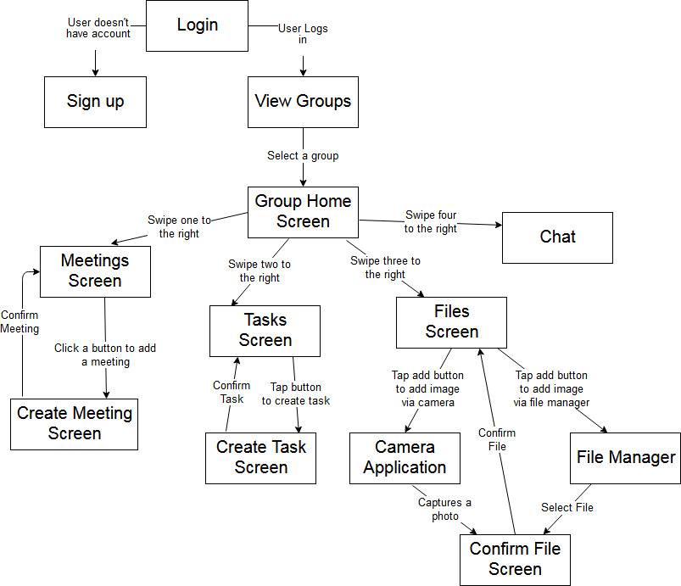

Figure 1. Application Flow Diagram

## 3. Design

## 3.1 Overall Components Overview

## 3.2 Mockups

## 3.3 Used Application Programming Interfaces

### 1. Firebase Authentication

### 2. Firebase Realtime Database

### 3. Firebase Storage

## 4. Application Structure

## 4.1 Packages

## 4.2 Activities

## 4.3 Services

## 4.4 Others

## 5. Data Structures

## 6. Testing

## 7. Conclusion

## 8. References